**Project Design Phase-II**

**Technology Stack (Architecture & Stack)**

|  |  |
| --- | --- |
| Date | 26 June 2025 |
| Team ID | SRGECVIP20251570 |
| Project Name | Revolutionizing Liver Care : Predicting Liver Cirrhosis using Advanced Machine Learning Techniques |
| Maximum Marks | 4 Marks |

**Technical Architecture:**

The Deliverable shall include the architectural diagram as below and the information as per the table1 & table 2

**Example: Order processing during pandemics for offline mode**

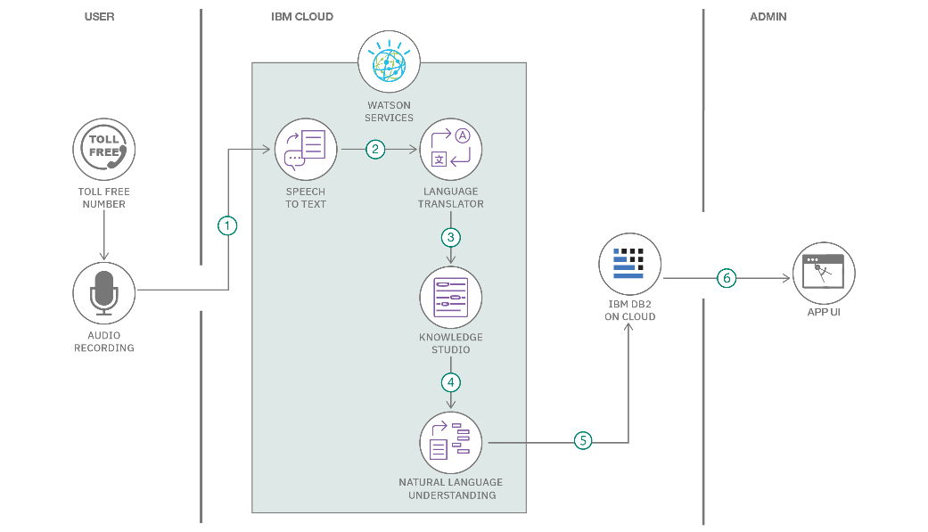**Reference:** [**https://developer.ibm.com/patterns/ai-powered-backend-system-for-order-processing-during-pandemics/**](https://developer.ibm.com/patterns/ai-powered-backend-system-for-order-processing-during-pandemics/)

Guidelines:

Include all the processes (As an application logic / Technology Block)

Provide infrastructural demarcation (Local / Cloud)

Indicate external interfaces (third party API’s etc.)

Indicate Data Storage components / services

Indicate interface to machine learning models (if applicable)

**Table-1 : Components & Technologies:**

| **S.No** | **Component** | **Description** | **Technology** |
| --- | --- | --- | --- |
| **1** | **User Interface** | **Web-based interface for doctors to input clinical data and view predictions** | **HTML, CSS, JavaScript, Streamlit** |
| **2** | **Application Logic-1** | **Handles input validation, user session, and data formatting** | **Python (Flask or FastAPI)** |
| **3** | **Application Logic-2** | **Preprocessing of clinical data (normalization, missing value handling)** | **Python (Pandas, NumPy)** |
| **4** | **Application Logic-3** | **Generates visual SHAP explanations for interpretability** | **SHAP Library (Python)** |
| **5** | **Database** | **Stores user inputs, predictions, and feedback** | **SQLite or PostgreSQL** |
| **6** | **Cloud Database** | **Cloud-hosted database for scalability** | **IBM Cloudant or Firebase Firestore** |
| **7** | **File Storage** | **Stores model files, logs, and SHAP plots** | **IBM Cloud Object Storage or Local FS** |
| **8** | **External API-1** | **Fetch patient-related clinical context or lab info from EHR APIs (optional)** | **HL7 FHIR API (optional)** |
| **9** | **External API-2** | **Identity verification for secure medical record access (optional)** | **Aadhaar API (if integrated)** |
| **10** | **Machine Learning Model** | **Predicts liver cirrhosis risk using clinical inputs** | **XGBoost / Random Forest (Python/sklearn)** |
| **11** | **Infrastructure (Server/Cloud)** | **Deployment of application on cloud or local testing** | **IBM Cloud Foundry / Docker / Kubernetes** |

**Table-2: Application Characteristics:**

| **S.No** | **Characteristics** | **Description** | **Technology** |
| --- | --- | --- | --- |
| **1** | **Open-Source Frameworks** | **Used for ML, explainability, and web interface** | **scikit-learn, SHAP, Streamlit, Flask** |
| **2** | **Security Implementations** | **Secure login, encrypted data storage, access control** | **HTTPS, JWT, OAuth2, IAM, SHA-256** |
| **3** | **Scalable Architecture** | **Modular 3-tier architecture with potential for microservices** | **REST API, Docker, Kubernetes** |
| **4** | **Availability** | **Highly available through cloud deployment and auto-scaling** | **IBM Load Balancer, Kubernetes Pods** |
| **5** | **Performance** | **Optimized ML pipeline, caching predictions, asynchronous requests** | **Redis Cache, Gunicorn, CDN (optional)** |

**References:**

[**https://c4model.com/**](https://c4model.com/)

[**https://developer.ibm.com/patterns/online-order-processing-system-during-pandemic/**](https://developer.ibm.com/patterns/online-order-processing-system-during-pandemic/)

[**https://www.ibm.com/cloud/architecture**](https://www.ibm.com/cloud/architecture)

[**https://aws.amazon.com/architecture**](https://aws.amazon.com/architecture)

[**https://medium.com/the-internal-startup/how-to-draw-useful-technical-architecture-diagrams-2d20c9fda90d**](https://medium.com/the-internal-startup/how-to-draw-useful-technical-architecture-diagrams-2d20c9fda90d)